Assignment #8 Predictive Ensemble Models by Joshua Troup

Q1: Looking at the test data set, what is the overall accuracy? What is the lift on the first decile?

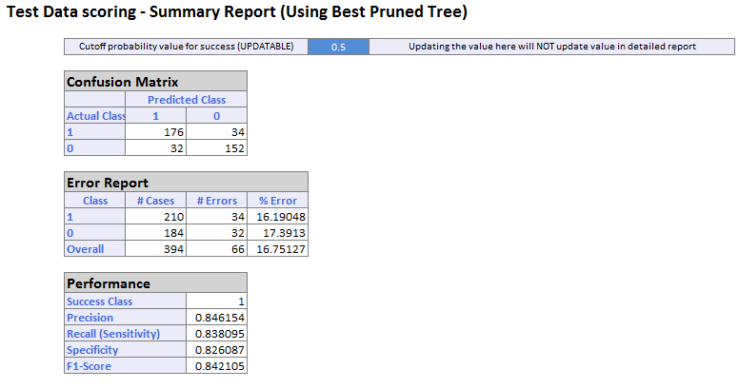

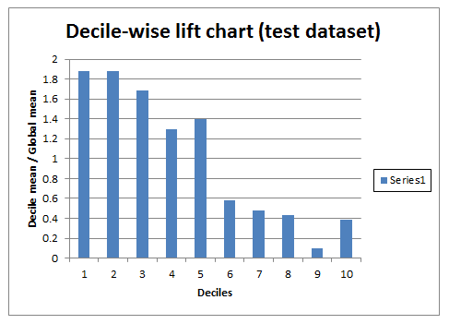

**66 cases out of 394 were misclassified resulting in a 16.75% error in accuracy. The lift on the first decile is approximately 1.9 times better when assigning a random competitive or noncompetitive value. Note: Decile 1 and 2 have same value.**

Q2: For the test data set, what is the overall accuracy? What is the lift on the first decile?

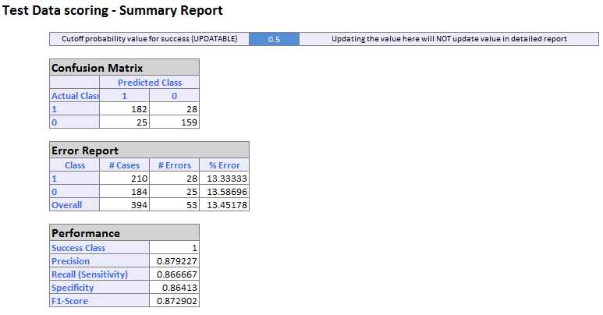

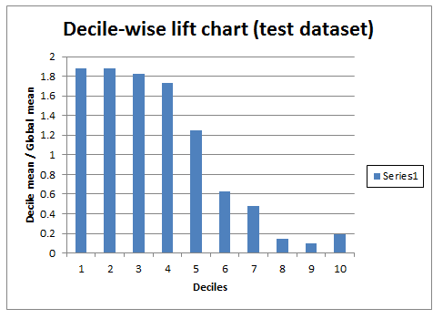

**53 cases out of 394 were misclassified resulting in a 13.45% error in accuracy. The lift on the first decile is approximately 1.9 times better when assigning a random competitive or noncompetitive value. Note: Decile 1 and 2 have same value.**

Q3: For the test data set, what is the overall accuracy? What is the lift on the first decile?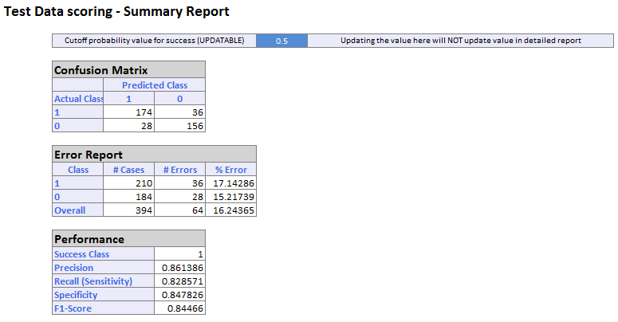

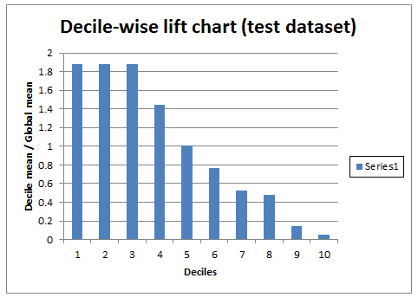

**64 cases out of 394 were misclassified resulting in a 16.24% error in accuracy. The lift on the first decile is approximately 1.9 times better when assigning a random competitive or noncompetitive value. Note: Decile 1, 2 and 3 all have equal value.**

Q4: For the test data set, what is the overall accuracy? What is the lift on the first decile?

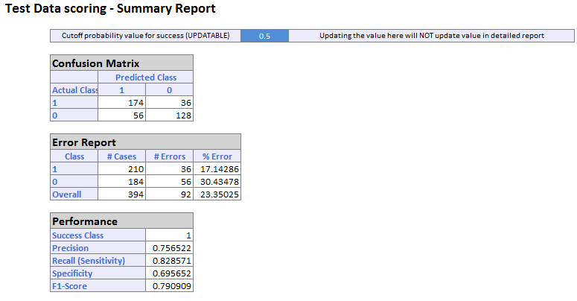

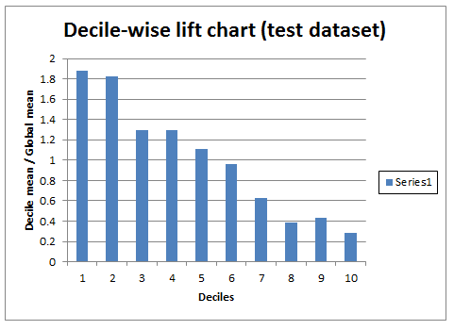

**92 cases out of 394 were misclassified resulting in a 23.35% error in accuracy. The lift on the first decile is approximately 1.9 times better when assigning a random competitive or noncompetitive value.**

Q5. Compare all the classifications and comment on the overall accuracy

**Boosting: This classification proves to be the most accurate out of the other three models. 53 cases out of 394 were misclassified resulting in a low 13.45% error in accuracy.**

**Bagging: This classification proves to come in a relatively close second place regarding accuracy. 64 cases out of 394 were misclassified resulting in a 16.24% error in accuracy.**

**Single Classification Tree: Third place was extremely comparable to “Bagging” model. 66 cases out of 394 were misclassified resulting in a 16.75% error in accuracy.**

**Random Trees: The least accurate model of the four is the Random Trees. 92 cases out of 394 were misclassified resulting in a 23.35% error in accuracy. This model has the highest percentage error in accuracy.**